Predicting Loan Defaults: Analyzing Key Factors Influencing Borrower Behavior

Introduction

Problem Statement

In the financial sector, accurately predicting loan defaults is crucial for minimizing risk and enhancing decision-making processes. This project, "Predicting Loan Defaults: Analyzing Key Factors Influencing Borrower Behavior," aims to develop a predictive model that identifies the likelihood of borrowers defaulting on their loans.
The challenge stems from the necessity to comprehend the fundamental factors that affect borrower behavior, such as credit history, income levels, credit score, and various demographic characteristics.
By leveraging historical loan data and applying advanced analytical techniques, this project seeks to:
- Identify key predictors of loan defaults.
- Develop a machine learning model to predict the probability of default for new loan applicants.
- Provide insights to financial institutions that can guide lending policies and risk management strategies.
Ultimately, this project aims to enhance the ability of lenders to assess risk, improve loan approval processes, and reduce financial losses associated with defaults.

Justification for Problem Solving
Risk Mitigation: Understanding the factors influencing loan defaults allows financial institutions to better assess risk, leading to informed lending decisions and reduced financial losses.
Enhanced Decision-Making: Accurate predictions enable lenders to tailor their loan approval processes, ensuring that only qualified borrowers receive loans, which can improve overall portfolio quality.
Economic Stability: By reducing default rates, lenders can contribute to greater economic stability and confidence in the financial system, benefiting both institutions and consumers.
Operational Efficiency: Implementing predictive models can streamline the loan approval process, making it faster and more efficient, thereby enhancing customer satisfaction.
By addressing this problem, stakeholders can create a more sustainable lending environment that balances profitability with responsible lending practices.

Pitching the Problem Statement to stakeholder

I will pitch the problem statement and the solution to the stakeholder by clearly highlighting the challenge, the opportunities, and the benefits.
The Challenge
Loan defaults can lead to substantial financial losses and impact our overall profitability. Understanding the underlying reasons why borrowers default is crucial. Factors such as credit history, income levels, and employment status play a vital role, but we currently lack a comprehensive approach to analyze these influences effectively.
The Opportunity
By developing a predictive model, we can:
- Mitigate Risk: Identify high-risk borrowers before approving loans, allowing us to make informed lending decisions.
- Enhance Decision-Making: Tailor our loan approval processes to ensure we support qualified applicants while minimizing exposure to defaults.
Benefits for Our Institution
- Improved Financial Stability: Reducing default rates will enhance our bottom line and strengthen our financial position.
- Operational Efficiency: Streamlining the approval process will lead to faster turnaround times and improved customer satisfaction.
Call to Action
I will propose that we invest in a project to analyze borrower behavior and develop a predictive model for loan defaults. This initiative will not only safeguard our interests but also position us as a leader in responsible lending practices. This will enable us to create a more sustainable and profitable lending environment.

Data Source

I obtained my data from Kaggle, specifically from the project titled "Mortgage Loan Default - Data Preprocessing." The dataset is available at the following URL: Mortgage Loan Default - Data Preprocessing. This resource provides a comprehensive collection of data relevant to mortgage loan defaults, which is essential for analyzing borrower behavior and developing predictive models.
The original dataset comprises approximately 148,000 records and 34 columns, including 33 features such as Age and Gender. The target variable, labeled "status," indicates whether a loan application defaulted (1) or did not default (0).

Exploratory Data Analysis

In the dynamic landscape of financial services, it's essential for lenders to understand and manage loan defaults. In the Exploratory Data Analysis, I have analyzed the role of key factor influencing loan default rates. The analysis reveals several key insights regarding loan defaults. Joint applicants exhibit the lowest default rates, indicating the importance of exploring demographic factors such as marital status and dependents. The similar credit score distributions among defaulting and non-defaulting borrowers suggest that credit scores alone may not adequately predict default risk, warranting further investigation with additional variables. Defaulted loans tend to have slightly higher median interest rates, while non-defaulting loans include outliers with even higher rates, emphasizing the need for careful management of outliers. Additionally, default cases demonstrate greater variability and higher median loan amounts, implying that larger loans are more prone to default, which may prompt lenders to tighten criteria for such loans. Finally, loans with pre-approval show a lower likelihood of default, highlighting a strong correlation between pre-approval status and reduced risk, thereby encouraging lenders to prioritize the pre-approval process.

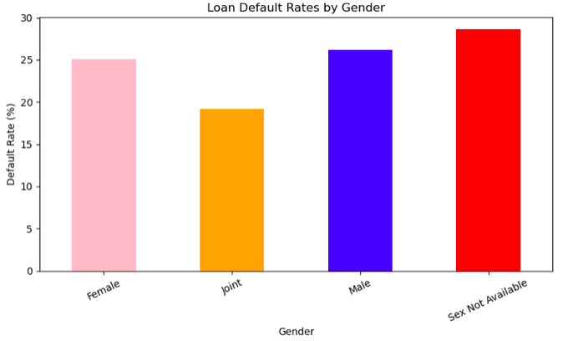 | 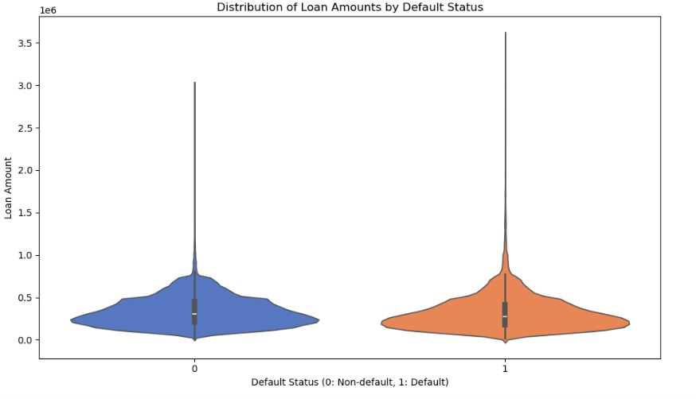
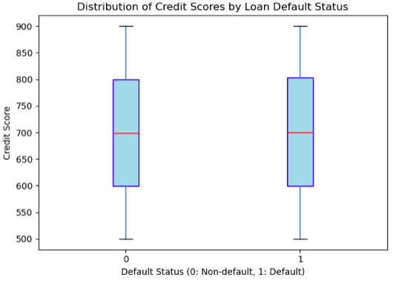 | 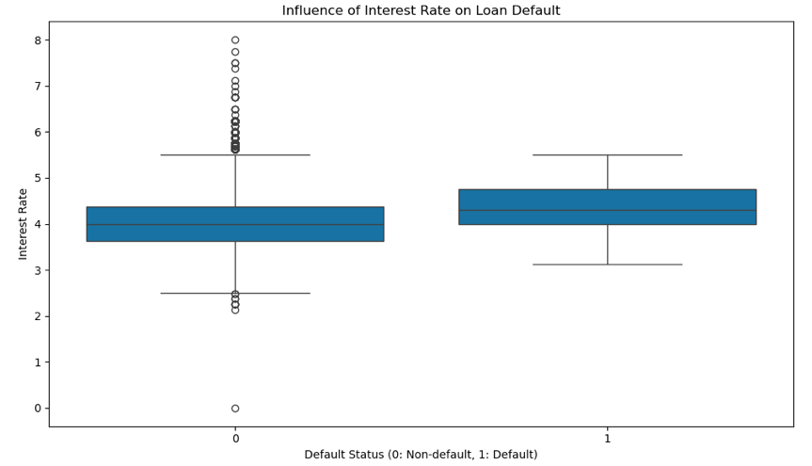

Data Preparation

As a part of the Data Preparation, I have performed a series of activities. First, I have dropped the below list of columns that are not essential to the analysis. These are columns that do not contribute to the analysis / learning of data and the columns that did not have any meaningful data/data points that could not be interpreted.
- dtir1
- submission_of_application
- ID
- year
- construction_type
- Secured_by
- loan_limit
- loan_type
- loan_purpose
- occupancy_type
- interest_category

Next, I have analyzed the list of unique values on categorical feature, this helped in understanding what features can be considered categorical and eventually can be encoded. I have created to category field by binning the rate of interest values which will help categorize the loan application to interest ranges.

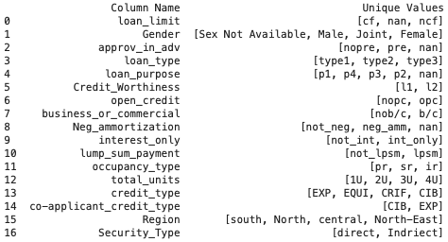 | 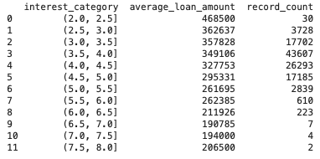

Additionally, I have added description columns for code columns like Loan Type, Loan Purpose, and Occupancy Type. For instance, values like type 1 and type 2 do not provide much context for visual interpretation compared to descriptions such as Conventional or Federal Housing Administration Insured (FHA). I derived these description fields for standard features from the Consumer Financial Protection Bureau (CFPB).

I have also introduced new features, such as Monthly EMI and Loan Amount Risk, to enhance the existing features. Additionally, I addressed missing values in columns that contained NaN values by employing different techniques tailored to each column. In some instances, I filled NaN values with the label "unknown," while in others, I used the mode to populate missing entries. For a few features, I replaced NaN values with the mean, and in one case, I used 0 to substitute for missing values.

Prior to handling Missing Values  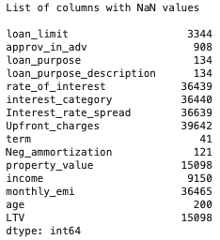 | After handling Missing Values  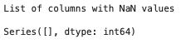

Finally, dummy variables are created to represent categorical variables as binary indicators, allowing them to be included in regression models and other statistical analyses. By converting categories into a series of 0s and 1s, dummy variables enable the model to interpret and utilize categorical data effectively. This transformation helps improve the model's accuracy and predictive power by ensuring that each category is appropriately represented, facilitating a more nuanced understanding of how different factors influence the outcome in the project.

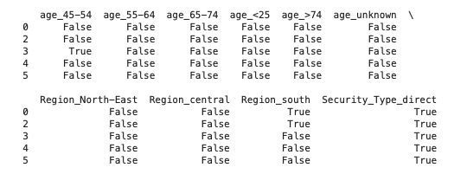

Model Building and Evaluating

After splitting data into Training and Test sets, I have begun by building a Linear Regression model and attempted to fit it to the dataset, but it performed poorly.
Results of Linear Regression Model

Next, I have created a pipeline and trained a K-Nearest Neighbors model for predictions, which showed improved accuracy. To enhance performance further, we applied Grid Search to identify the optimal hyperparameters, resulting in better outcomes.
Prediction Accuracy from Pipeline for KNN

Best Parameter and Improvement in Prediction Accuracy after Grid Search is applied
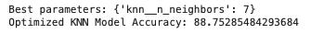

Subsequently, I have developed multiple classifiers, including Logistic Regression, Decision Tree, KNN, and Random Forest. Ultimately, the Random Forest model emerged as the most accurate for predicting the target variable, "Loan Default Status," achieving the highest accuracy.

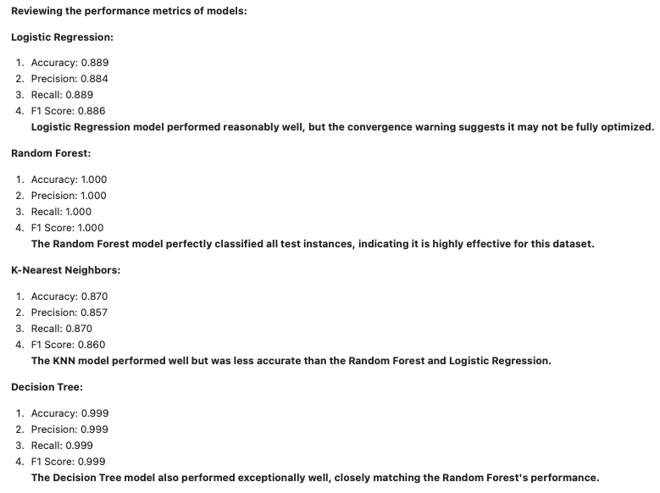
Best Model

The Random Forest emerged as the best model based on accuracy, achieving perfect scores across all metrics, suggesting it is the most reliable option for the given dataset. While several models performed well, the Random Forest classifier demonstrated the highest performance, highlighting its robustness for this classification task.

Warning

However, the perfect results from the Random Forest model may indicate potential overfitting, particularly if the test set is not sufficiently large or diverse. Overfitting occurs when the model learns the training data too thoroughly, including noise and outliers, which may not generalize well to new, unseen data. Further investigation may be necessary to assess the risk of overfitting.

Assess Overfitting

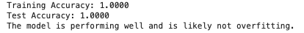
The model correctly predicts all samples in both the training and test sets. This suggests that the task may be relatively simple, or the model has learned the underlying patterns flawlessly. Overfitting occurs when a model performs well on the training data but poorly on the test data. In this case, test accuracy is equally high (1.0000), the model generalizes well to unseen data, and it is evident that overfitting is not present.

Conclusion

What does the analysis/model building tell you?

Based on the prediction accuracy of Linear Regression Model, it is clearly evident that the relationship between input and target variables. Based on fitting various models to the dataset, Random Forest Model emerged as the winner achieving a perfect 100% accuracy on validation set based on the training.

Is this model ready to be deployed?

Based on the performance metrics—including Accuracy, Precision, Recall, and F1 Scores—it is evident that the model is well-prepared for deployment. These metrics indicate a robust and reliable model, demonstrating its effectiveness in predicting loan defaults.

What are your recommendations?

It is advisable to continuously monitor its performance to maintain accuracy and reliability standards. Additionally, implementing a feedback mechanism is crucial for gathering insights from both model predictions and actual outcomes, ensuring that the loan default prediction model remains effective, compliant, and aligned with business objectives.

What are some of the potential challenges or additional opportunities that still need to be explored?

As we gather a significant amount of new data, we can incorporate it to retrain our model, establishing a recurring mechanism to ensure it remains aligned with current trends.

However, as the dataset grows, the Random Forest Regression model may become increasingly time-consuming and challenging to train effectively. Additionally, this model is particularly sensitive to changes; if any parameters, noise, or environmental factors shift, its effectiveness can diminish. Addressing these challenges will be crucial for maintaining model performance and exploring further opportunities for enhancement.

